Parish Councillors are duly summoned to attend a Briercliffe with Extwistle Parish Council meeting to be held Thursday 22nd July 2026 at 5.00pm at the Community Centre, Jubilee Street, Briercliffe. BB10 2JD
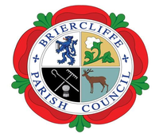
Members of the public are invited to attend.
BRIERCLIFFE WITH EXTWISTLE PARISH COUNCIL
PARISH COUNCIL MEETING
Thursday 22nd July 2026 at 5.00pm
Welcome
- Apologies for absence and reasons given
- Declarations of Disclosable Pecuniary Interests
- To approve the AGAR from the internal Auditor.
- Dates of the next parish council meetings and strategy meetings.

